IT:

Add an asset in IT
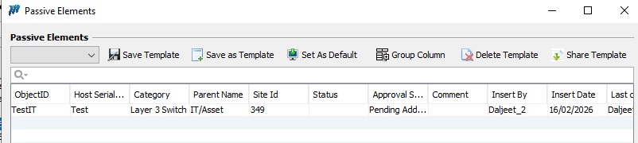

Run the Sync

Checked in UM asset available :

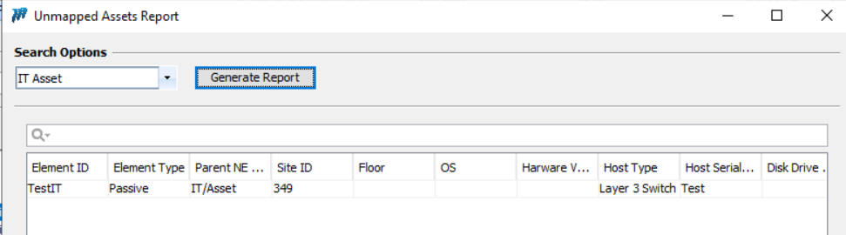

Put financials on it:
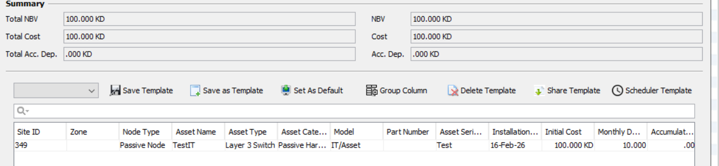

Now changes the HSN at Inventory level
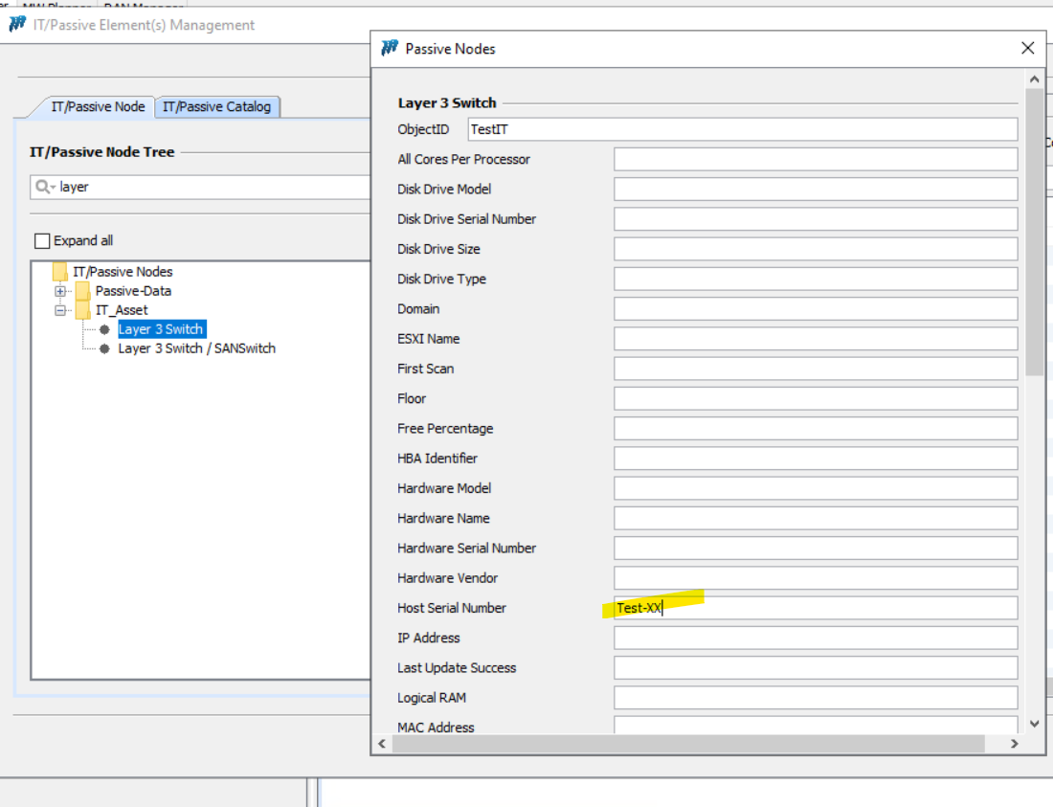
Run the sync process:

No new entry created at UM:
